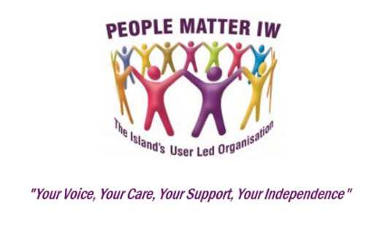
People Matter IW is here for any local person, from birth to end of life and without discrimination, who defines themselves as having support needs.

Are you living with a disability or impairment? Are you in receipt of support services, a Direct Payment or Personal Budget for your care? Are you an older person or a family or unpaid Carer? Do you have health concerns, a learning disability or difficulty? People Matter IW is the organisation which can help to give you a voice. You can register with us by completing this form and sending it to: People Matter IW, The Independent Support Centre, 1 & 2 Bernard Way, Newport, Isle of Wight, PO30 5YL. Tel: 01983 685348
Name: |  | …………………………………….…………………………………….…….
E mail: |  | …………………………………….………………………………….……….  (E mail is the most cost-effective way for us to communicate but a postal address is required where one cannot be provided)
Address: |  | ……………………………………….…………………….………………….
Postcode: |  | …………………………………….…………………………………….…….
Phone: |  | …………………………………….………………………….……………….
Please indicate your subject(s) of interest: (Tick as many as are appropriate)

Carer
Learning Disability or Difficulty
Long Term Health Condition(s)
Attention Deficit Hyperactivity Disorder (ADHD)
Older People
Autistic Spectrum Disorder
Physical and/or Sensory Disability
Other Disability

(Please be aware when ticking to receive more than one set of subject specific information you may receive the same e mail more than once. Please accept our apologies for any inconvenience this may cause you).

In order that People Matter IW can comply with the General Data Protection Regulations, please sign below to specifically agree that your details can be kept on a secure registration database. Please be assured that your details will not be passed on to any third party without your permission.

Signed: ………………………………………………………….. Date: ………/………/………

_______________________________________________________________________
Office use only: Registration Number: PMIW 0031 Individual Registration Form v10 Retention Period 6 years

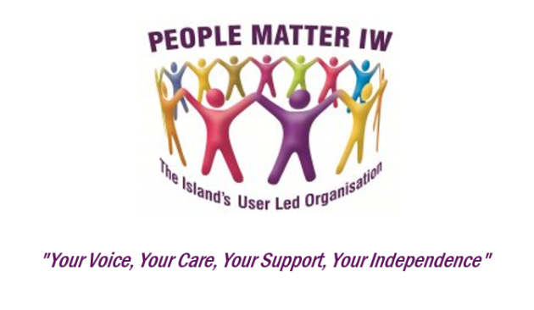

Registering with People Matter IW is FREE!

As part of its work People Matter IW assists with, supports, hosts or facilitates, several groups for a wide range of lsland residents with differing support needs. This includes Older People, people with Learning Disabilities, Autism and Autistic Spectrum Conditions, Carers, adults with Attention Deficit Hyperactivity Disorder (ADHD), people with Long-Term Conditions and the Isle of Wight Parent Carer Forum - Parents Voice IW. People Matter IW also work closely with many other local, affiliated organisations involved in and around health and social care.

In recent times there have been many changes in the provision of both health and social care. Because of this there is a real need for much more involvement from the people who use the services, for these people to be more fully consulted and for everyone to have a direct say in every single element of both their care and any change in service delivery that may affect them both as groups and as individuals. People Matter IW exists to embrace and assist this approach.

The groups we work with are encouraged to bring forward and discuss their own priorities and are actively supported to hold the authorities to account. They are also free to raise issues and concerns that they feel need to be investigated, challenged, discussed and/or addressed. This is where you can help to influence the future.

Our registration form is overleaf, and we would encourage you to sign up with People Matter IW.

Please forward your form to us at:

People Matter IW, The Independent Support Centre, 1 & 2 Bernard Way, Newport, Isle of Wight, PO30 5YL.

More details or information can be obtained either from the website at:

www.peoplematteriw.org, by e mail at admin@peoplematteriw.org or by phone on 01983 685348.

PMIW 0031 Individual Registration Form v10 Retention Period 6 years

